Briefing Note #2

Task:

Consider a pre-pandemic situation. It is January of 2020 and you are a senior economist in the Department of Finance unware of a COVID-19 pandemic. These are normal times and you are tasked to brief the Minister of Finance (at the time it was Bill Morneau, not Chrystia Freeland) on the current state of Canada’s debt and debt-to-GDP ratio (that is, as it was on January 2020). Furthermore, you want to provide the Minister with key considerations for the planning of next year’s budget (remember that there is no pandemic foreseen). That is, outline key considerations for the Minister who may have spending plans for next year’s budget that are likely to be similar to the spending and revenue plans that have been carried out in the past 4 years, 2015-2019.

- Your briefing note is “For Information Only”; however, ensure that it has a well-developed “Key Considerations” section.

- Along with your task outline in point 1 above, develop your briefing note “Issue” after reading the two articles below. You are free/encouraged to look at additional resources. Remember that you are operating in normal, non-pandemic times.

===============================

Published on Fraser Institute (https://www.fraserinstitute.org)

Article 1: Mr. Prime Minister, the good times won’t last forever
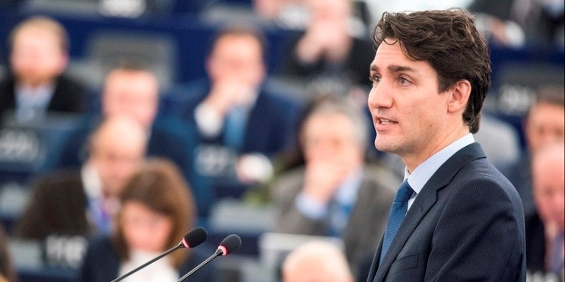
Appeared in the National Newswatch, May 27, 2019
Throughout its mandate, rather than acting to reduce the federal budget deficit, the Trudeau government has made “investments” in the form of more and more spending. Of course, this plan relies on a wave of good fortune, with positive economic growth and higher-than-expected revenues each year, to finance the

government’s proclivity for spending. However, recent information from the Parliamentary Budget Officer (PBO) and Statistics Canada casts serious doubt on the viability of this plan moving forward.
According to the PBO, the 2018-19 deficit in Ottawa will be $800 million higher than projected in the government’s latest budget released in March. The PBO projects a drop in expected revenues. In other words, the government can’t count on its original revenue projections—let alone higher-than-expected revenues—to fund its penchant for spending.
But last year’s higher-than-anticipated deficit should not come as a surprise. Prime Minister Trudeau has spent more money (on a per-person inflation-adjusted basis) than any prime minister in Canadian history. In fact, federal per-person program spending reached an all-time high at $8,869 in 2018-19. For context, the previous per-person high ($8,847) was recorded during the Great Recession in 2009.
Of course, more spending means more new debt. By the end of his term this fall, Prime Minister Trudeau will have increased federal debt (again, per person and inflation-adjusted) by 5.6 per cent , which is more than any other prime minister who did not experience a world war or recession while in office. Put differently, Justin Trudeau is the only prime minister since 1895 to increase the per-person debt burden without presiding over a global conflict or economic downturn.
Four consecutive federal deficits have meant that each Canadian has acquired $1,725 more in federal debt since this government took office. Therefore, it’s important to realize that future generations will ultimately pay higher taxes tomorrow to finance today’s debt growth. And so it’s worth asking, what has this record accumulation of spending and debt brought us?
For starters, recent sluggish economic growth. StatsCan has revealed that the Canadian economy contracted by 0.1 per cent in February. Falling resource production in mining and oil and gas caused those sectors to shrink again for the sixth consecutive month. Output in the finance and manufacturing sectors dropped as well. Overall, the economy has now shrunk in four of the past six months .
In light of this news, there’s now a heightened risk of recession occurring in the near future. And that could pose serious problems for Canada’s fiscal situation moving forward.
In our recent study , we estimated that the federal deficit could potentially eclipse $34 billion before any stimulus measures if an economic downturn occurred this year. And the negative effects on federal finances could last much longer. Depending on the severity of the recession, the accumulated deficit over the next five years could total between $115 billion and $142 billion. As a result, the debt burden for Canadians—the people who pay the interest on Ottawa’s debt—would continue to grow.
Massive and repeated spending increases, accompanied by rapidly accumulating debt, have defined this government’s fiscal policy. Clearly, it can’t continue down its current path of hoping the good times will roll forever. Economic growth is now waning and government revenues will not always exceed expectations. The strategy of trying to balance the budget on a wing and a prayer is destined for failure.

Article 2: Stimulus spending will likely harm Canadian economy—not help it

Appeared in National Newswatch, June 25, 2020


As the federal and provincial governments shift their focus to economic recovery, there will be heightened calls for fiscal stimulus in an attempt to kick-start the economy. However, a new study by the Fraser Institute demonstrates that, based on past experience, stimulus measures will almost certainly be ineffective.
Fiscal stimulus refers to additional government spending and/or tax relief used in an effort to mitigate the impact of a recession and speed up economic recovery. The theory assumes that stimulus measures can influence people to spend more and create a positive ripple effect in the economy.
Let’s see how this theory holds up.

During the 2008-09 recession, the federal government enacted a two-year $47 billion stimulus package focused mainly on spending measures, such as public infrastructure and subsidies to business, with the hopes of improving economic growth. Although the economy did recover, a 2010 study found that government spending on infrastructure had little to no effect on Canada’s economic growth during the recovery. Instead, the data demonstrated that private- sector investment and increased net exports were the drivers of economic recovery.
Stimulus efforts in the United States provided similar results. Stanford University professor John Taylor analyzed the impact of providing temporary tax rebates to American households to stimulate consumer spending and thereby grow the economy during the last recession. His research showed that the stimulus measures were ineffective at increasing spending because households largely chose to use the rebates for savings or paying down personal debt. Indeed, the U.S. stimulus package during the 2008-09 recession had little to no effect on economic growth and instead only resulted in additional government debt.

In both the U.S. and Canadian experience in 2008-09, infrastructure spending was used in an effort to kick-start the economy. The problem with this approach is that infrastructure projects that are deemed to be “shovel ready” actually take significant time to plan and implement. In fact, experience shows that the economic recovery had already begun before the shovels hits the ground. By the time government infrastructure spending occurred, it was competing with the private sector for resources, resulting in increased costs and fewer private-sector projects.
Evidence from University of California San Diego professor Valerie Ramey and Harvard University professor Robert Barro emphasizes the issue with stimulus spending, using a concept called the “fiscal multiplier”, which shows the impact that each additional dollar of government spending has on the economy. In theory, a multiplier greater than 1.0 indicates that stimulus works because a $1 increase in government spending will increase overall economic output by a value greater than $1. Their research, however, demonstrates that the multiplier for stimulus spending is likely below 1.0, indicating that stimulus spending actually crowds out private economic activity that would otherwise have occurred and therefore does not stimulate the economy.
Further, research from late Harvard University professor Alberto Alesina found that increased government spending is associated with lower economic growth. Specifically, his research showed that a 1.0 percentage point increase in government spending relative to the size of the economy is associated with a 0.75 percentage point reduction in economic growth. Simply put, increased government spending and stimulus measures could actually be a hindrance rather than a help to Canada’s economy.
Before implementing any fiscal stimulus, Canadian policymakers must consider the empirical evidence, which raises significant doubts about whether fiscal stimulus can achieve its objective to kick-start the economy. Indeed, past experience suggests stimulus will not improve the Canadian economy and may even be a detriment to it.

